https://www.thelibertybeacon.com/a-century-ago-rockefellers-funded-eugenics-initiative-to-sterilize-15-million-americans/

(Volg bovenstaande link voor het hele artikel)

A Century Ago: Rockefellers Funded Eugenics Initiative to Sterilize 15 Million Americans
December 14, 2014 This article was posted by TLB Staff HEALTH, WORLD 2
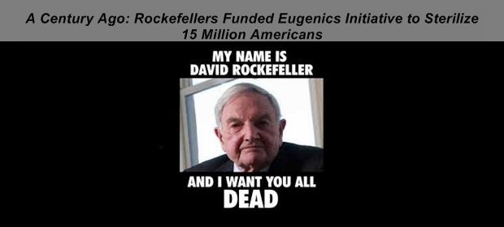
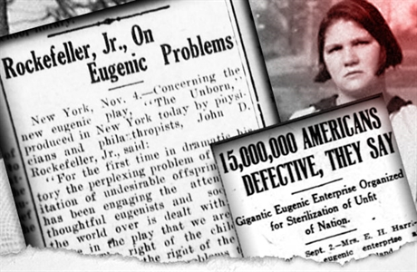
December 13, 2014 by Aaron Dykes and Melissa Melton Posted in Olds
Some people are still under the impression that the Rockefeller Foundation is all about philanthropy: helping people and saving lives. Those people are Bill Gates and Bill Gates and Warren Buffet.
In reality, the Rockefellers have been one of the largest financial backers and drivers of the eugenics and the depopulation agenda for over a century now.
Check out these 1915 newspaper clippings we came across in research.
The first is from The Salem Daily Capital Journal printed Thursday, November 4th, 1915.

